|  |
| --- |
| **Fairmont Neighborhood School 1550 Vyse Ave**  **Bronx, NY 10460**  **Tel: 718-860-5210**  **Fax: 718-860-5215** |

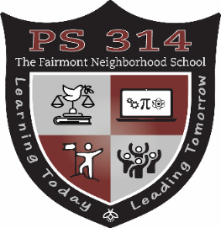

**Septiember 2023**

**Calendario**

|  |  |  |  |  |  |  |
| --- | --- | --- | --- | --- | --- | --- |
| **SUN** | **MON** | **TUE** | **WED** | **THU** | **FRI** | **SAT** |
|  |  |  |  |  | **1** | **2** |
| **3** | **4**  **Día laboral** | **5** | **6** | **7**  **Primer dia de escuela**    **[* * * *](https://www.schools.nyc.gov/calendar/contentdetails/2021/09/13/default-calendar/first-day-of-school-for-students)**  **3Pk/Pk**  **Orientation** | **8** | **9** |
| **10** | **11** | **12** | **13**  **DLT**  **Reunión 9:30am**  * * * *  **[Reunión D12 del Consejo de la CEC](https://www.schools.nyc.gov/calendar/contentdetails/2021/09/13/default-calendar/first-day-of-school-for-students)**  **[6pm](https://www.schools.nyc.gov/calendar/contentdetails/2021/09/13/default-calendar/first-day-of-school-for-students)** | **14**  **Reunión de CPAC**  **9:30am**  **\* * * \***  **Reunión de padres de regreso a la escuela Vitual**  **4:30pm-7:30pm** | **15** | **16** |
| **17** | **18** | **19**  **PA Parent**  **Meeting**  **9am** | **20**  **Reunión de SLT**  **3:30pm** | 21 | **22**  **Trae a tu papá a la escuela**  **8am** | **23** |
| **24** | **25**  **Yom Kippur**  **No School** | **26** | **27** | **28** | **29** | **30** |